# 项目名称

Spring 训练

# 小组成员

16301054 尹业立

16301056 赵江宁

# 功能介绍

用户登录，员工信息增删改查、web缓存

# 使用技术

Spring boot,

Jpa

Mybatis

Web cache

# 代码结构

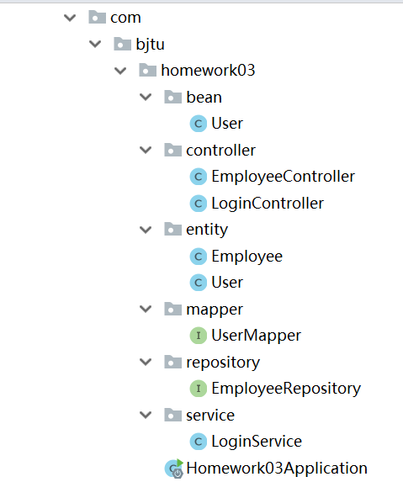

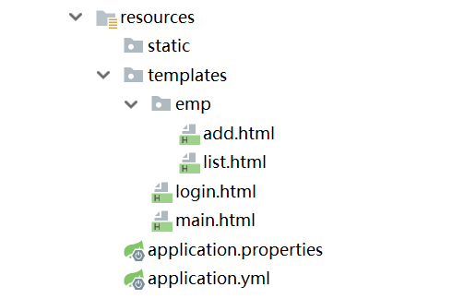

EmployeeController

**package** com.bjtu.homework03.controller;  
  
**import** com.bjtu.homework03.entity.Employee;  
**import** com.bjtu.homework03.repository.EmployeeRepository;  
**import** org.slf4j.Logger;  
**import** org.slf4j.LoggerFactory;  
**import** org.springframework.beans.factory.annotation.Autowired;  
**import** org.springframework.stereotype.Controller;  
**import** org.springframework.ui.Model;  
**import** org.springframework.web.bind.annotation.*;  
  
**import** java.util.Collection;  
**import** java.util.List;  
  
@Controller  
**public class** EmployeeController {  
 Logger **logger** = LoggerFactory.*getLogger*(getClass());  
 *//注入* @Autowired  
 EmployeeRepository **employeeRepository**;  
  
 *//查询所有员工* @GetMapping(**"/emps"**)  
 **public** String list(Model model){  
 List<Employee> employees = **employeeRepository**.findAll();  
 *//放到请求域中* model.addAttribute(**"emps"**,employees);  
  
 *//thymeleaf 默认拼串  
 //classpath: /templates/emp/list.html* **return "emp/list"**;  
 }  
  
 *//员工添加页面* @GetMapping(**"/emp"**)  
 **public** String toAddPage(){  
 *//到添加页面* **return "emp/add"**;  
 }  
  
 *//员工添加* @PostMapping(**"/emp"**)  
 **public** String addEmp(Employee employee){  
 *//来到员工id列表表页面* System.***out***.println(employee);  
 **employeeRepository**.save(employee);  
 *//redirect 重定向地址  
 //forward 转发地址* **return "redirect:/main"**;  
 }  
  
 *//到修改页面，查出当前员工，在页面回显* @GetMapping(**"/emp/{id}"**)  
 **public** String toEditPage(@PathVariable(**"id"**) Integer id,Model model){  
 Employee e = **employeeRepository**.findOne(id);  
 model.addAttribute(**"emp"**,e);  
 *//回到修改页面（add是一个修改添加2合1的）* **return "/emp/add"**;  
 }  
  
 *//员工修改* @PutMapping(**"/emp"**)  
 **public** String updateEmployee(Employee employee){  
*// System.out.println(employee);* **logger**.info(**"修改"**);  
 **employeeRepository**.save(employee);  
 **return "redirect:/main"**;  
 }  
  
 *//员工删除* @DeleteMapping(**"/emp/{id}"**)  
 **public** String deleteEmployee(@PathVariable(**"id"**) Integer id){  
 **employeeRepository**.delete(id);  
 **logger**.info(**"删除"**);  
 **return "redirect:/main"**;  
 }  
  
}

LoginController

**package** com.bjtu.homework03.controller;  
  
**import** com.bjtu.homework03.service.LoginService;  
**import** org.slf4j.Logger;  
**import** org.slf4j.LoggerFactory;  
**import** org.springframework.beans.factory.annotation.Autowired;  
**import** org.springframework.stereotype.Controller;  
**import** org.springframework.web.bind.annotation.PostMapping;  
**import** org.springframework.web.bind.annotation.RequestMapping;  
**import** org.springframework.web.bind.annotation.RequestParam;  
  
**import** javax.servlet.http.HttpSession;  
**import** java.util.Map;  
  
@Controller  
**public class** LoginController {  
  
 Logger **logger** = LoggerFactory.*getLogger*(getClass());  
  
 @RequestMapping({**"/"**, **"/login"**, **"login.html"**})  
 **public** String login() {  
 **return "login"**;  
 }  
  
 @RequestMapping({**"/main"**, **"main.html"**})  
 **public** String main() {  
 **return "main"**;  
 }  
  
 @Autowired  
 LoginService **loginService**;  
  
 @PostMapping  
 @RequestMapping(**"user/loginPost"**)  
 **public** String loginPost(@RequestParam(**"uname"**) String uname,  
 @RequestParam(**"upwd"**) String upwd,  
 Map<String, Object> map,  
 HttpSession session) {  
 **if** (**loginService**.Login(uname, upwd)) {  
 *//登陆成功* **logger**.info(**"login ok"**);  
 session.setAttribute(**"loginUser"**, uname);  
 **return "redirect:/main"**;*//重定向到页面，而不是使用/user/loginPost链接* } **else** {  
 *//登录失败* **logger**.info(**"login not ok"**);  
 map.put(**"msg"**, **"用户名密码错误"**);  
 *//返回的页面 login.html* **return "redirect:/"**;  
 }  
 }  
}

UserMapper

**package** com.bjtu.homework03.mapper;  
  
**import** com.bjtu.homework03.bean.User;  
**import** org.apache.ibatis.annotations.Mapper;  
**import** org.apache.ibatis.annotations.Param;  
**import** org.apache.ibatis.annotations.Select;  
  
@Mapper  
**public interface** UserMapper {  
 @Select(**"select * from users where uname=#{uname} and upwd=#{upwd}"**)  
 **public** User getUser(@Param(**"uname"**) String uname, @Param(**"upwd"**) String upwd);  
  
}

LoginService

**package** com.bjtu.homework03.service;  
  
**import** com.bjtu.homework03.mapper.UserMapper;  
**import** org.slf4j.Logger;  
**import** org.slf4j.LoggerFactory;  
**import** org.springframework.beans.factory.annotation.Autowired;  
**import** org.springframework.cache.annotation.Cacheable;  
**import** org.springframework.stereotype.Service;  
  
@Service  
**public class** LoginService {  
 Logger **logger** = LoggerFactory.*getLogger*(getClass());  
 @Autowired  
 UserMapper **userMapper**;  
  
 @Cacheable(cacheNames = {**"login"**})  
 **public boolean** Login(String uname,String upwd){  
 **logger**.info(**"\n登录信息：\n账号："**+uname+**"\n密码："**+upwd);  
 **if** (**userMapper**.getUser(uname,upwd) != **null**){  
 **return true**;  
 }**else** {  
 **return false**;  
 }  
 }  
}

Employee

**package** com.bjtu.homework03.entity;  
  
**import** com.sun.corba.se.spi.presentation.rmi.IDLNameTranslator;  
**import** org.hibernate.annotations.Generated;  
  
**import** javax.persistence.*;  
**import** java.util.Date;  
  
*//使用JPA注解配置映射关系*@Entity *//告诉jpa这是一个实体类*@Table(name = **"employees"**) *//指定和哪个数据表对应；如果省略，默认表名字是类名小写***public class** Employee {  
  
 @Id  
 @GeneratedValue(strategy = GenerationType.***IDENTITY***) *//自增主键* **private** Integer **id**;  
 @Column  
 **private** String **name**;  
 @Column  
 **private** Integer **age**;  
 @Column  
 **private** Integer **sex**;  
 @Column  
 **private** Date **birth**;  
 @Column  
 **private** Long **phone**;  
  
  
 **public** Integer getId() {  
 **return id**;  
 }  
  
 **public void** setId(Integer id) {  
 **this**.**id** = id;  
 }  
  
 **public** String getName() {  
 **return name**;  
 }  
  
 **public void** setName(String name) {  
 **this**.**name** = name;  
 }  
  
 **public** Integer getAge() {  
 **return age**;  
 }  
  
 **public void** setAge(Integer age) {  
 **this**.**age** = age;  
 }  
  
 **public** Integer getSex() {  
 **return sex**;  
 }  
  
 **public void** setSex(Integer sex) {  
 **this**.**sex** = sex;  
 }  
  
 **public** Date getBirth() {  
 **return birth**;  
 }  
  
 **public void** setBirth(Date birth) {  
 **this**.**birth** = birth;  
 }  
  
 **public** Long getPhone() {  
 **return phone**;  
 }  
  
 **public void** setPhone(Long phone) {  
 **this**.**phone** = phone;  
 }  
}

User

**package** com.bjtu.homework03.entity;  
  
**import** javax.persistence.*;  
  
*// 使用jpa註解配置映射關係*@Entity *//告訴jpa這是一個實體類(和數據表映射的類)*@Table(name = **"users"**) *// 指定和哪個數據表對應***public class** User {  
  
 @Id *//這是一個主鍵* @GeneratedValue(strategy = GenerationType.***IDENTITY***) *// 主鍵生成策略設爲自增* **private** Integer **id**;  
  
 @Column(name = **"uname"**, length = 50) *// 這是和數據表對應的一個列* **private** String **uname**;  
 @Column *// 省略默認列名爲屬性* **private** String **upwd**;  
  
 **public** Integer getId() {  
 **return id**;  
 }  
  
 **public void** setId(Integer id) {  
 **this**.**id** = id;  
 }  
  
 **public** String getUname() {  
 **return uname**;  
 }  
  
 **public void** setUname(String uname) {  
 **this**.**uname** = uname;  
 }  
  
 **public** String getUpwd() {  
 **return upwd**;  
 }  
  
 **public void** setUpwd(String upwd) {  
 **this**.**upwd** = upwd;  
 }  
}

# 运行情况

## 登录

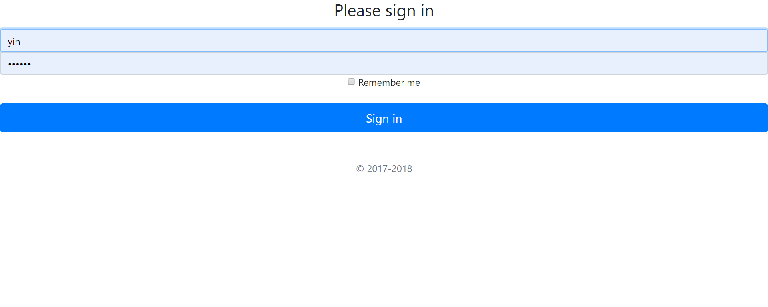

## 增加员工信息

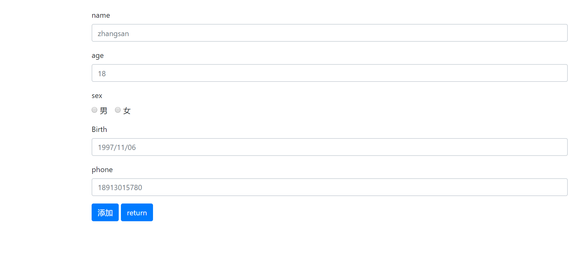

## 删除员工信息

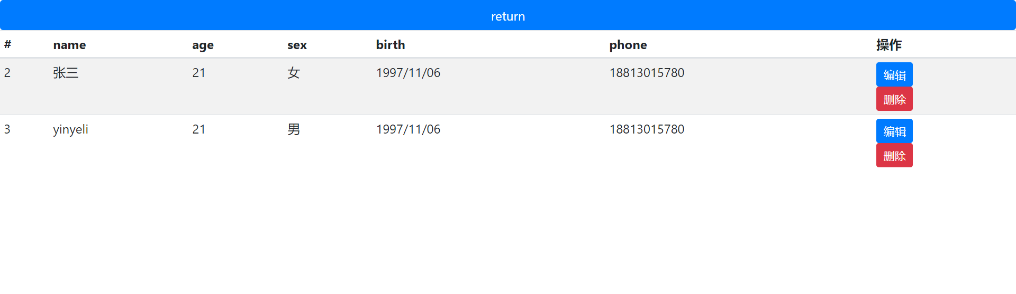

## 修改员工信息

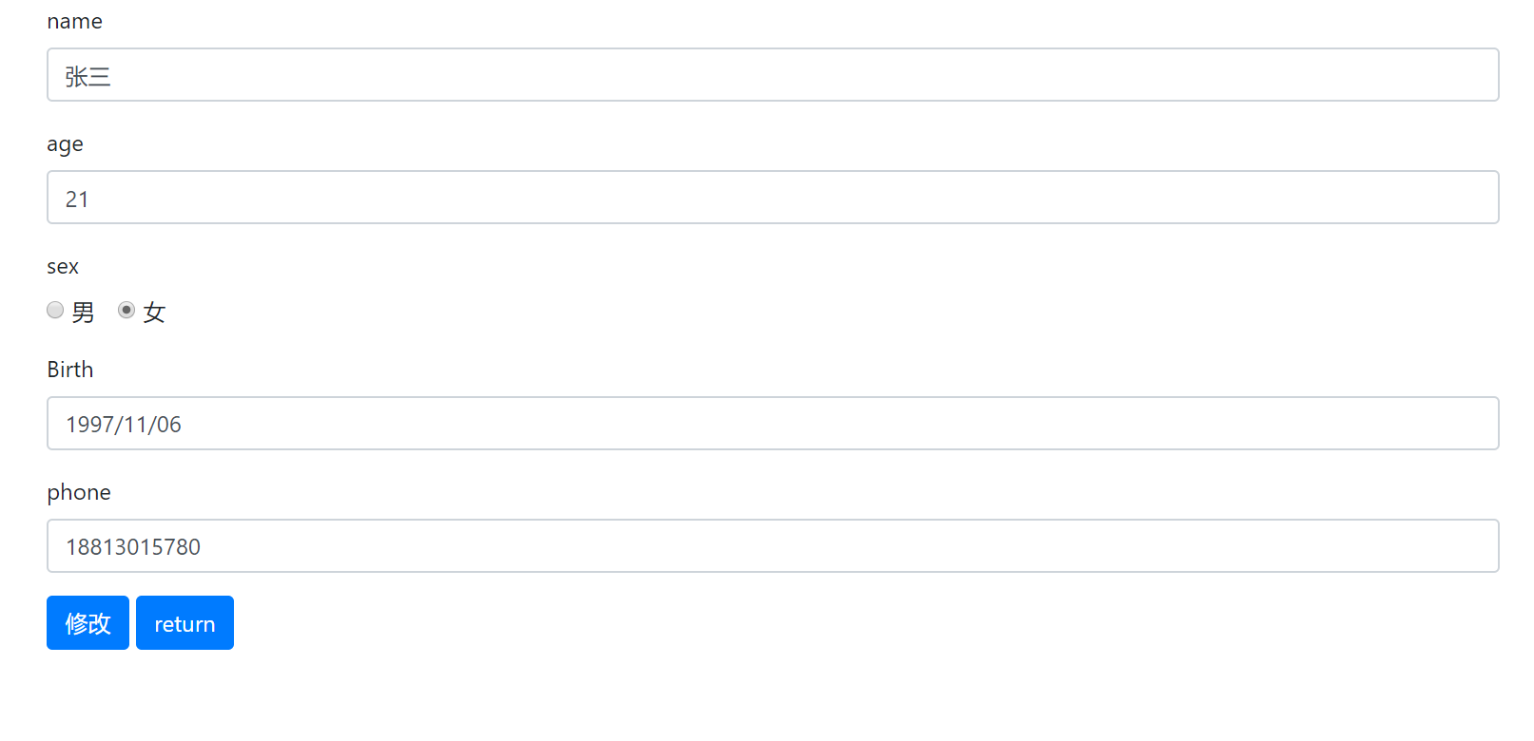

## 查询员工信息

